Day-5

Testing and Backend Refinement

“Food Restaurant”

1. Functional Deliverables:

* Screenshots or recordings show casing functional and responsive.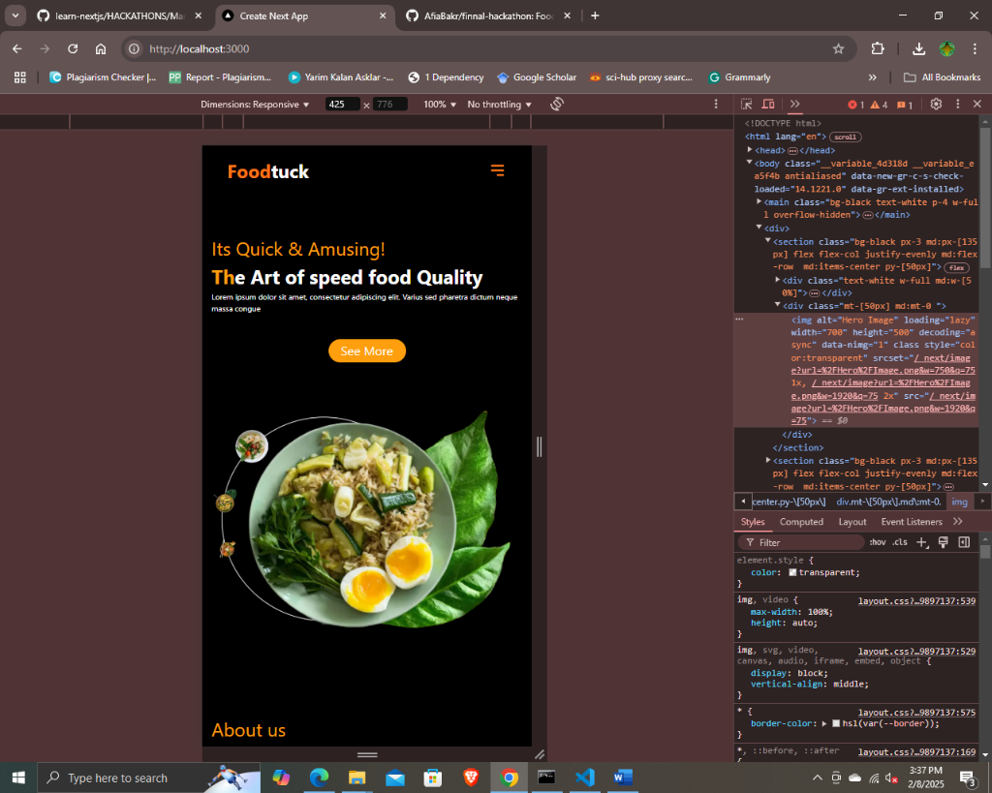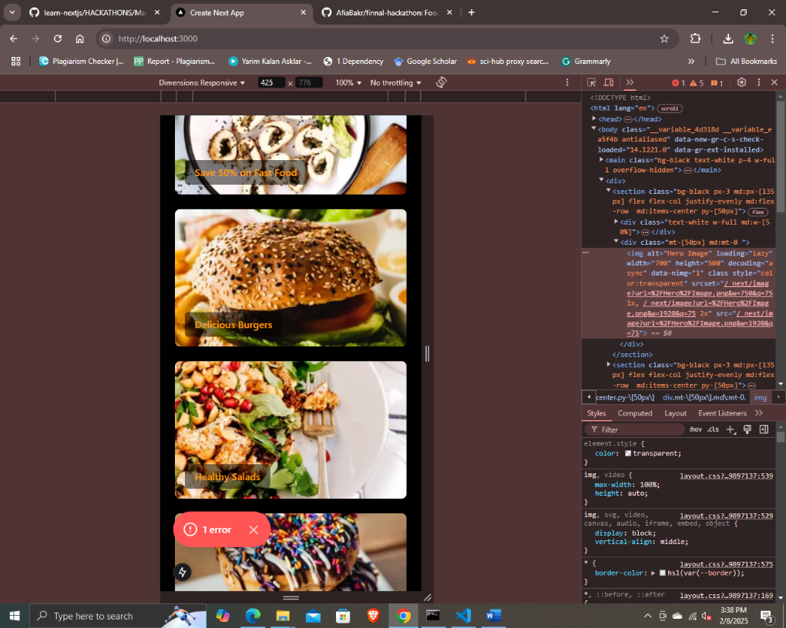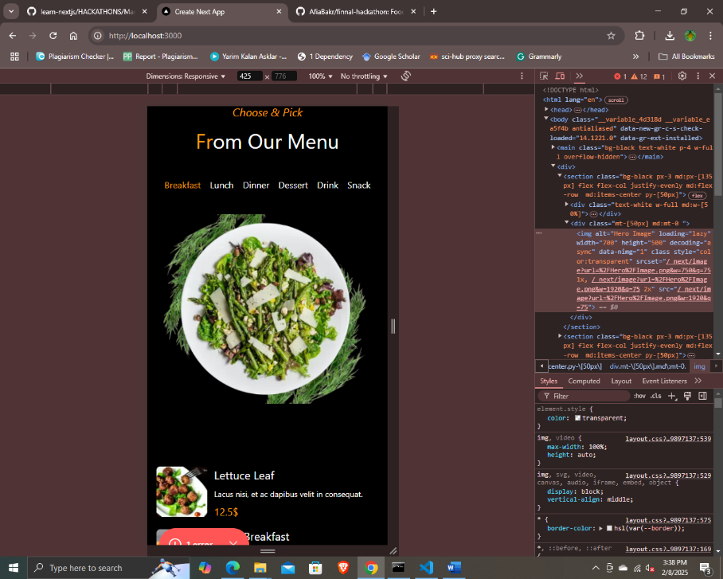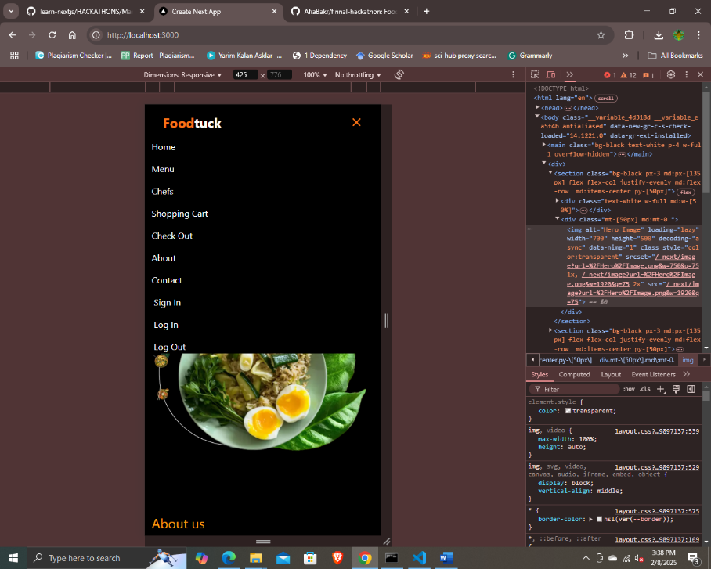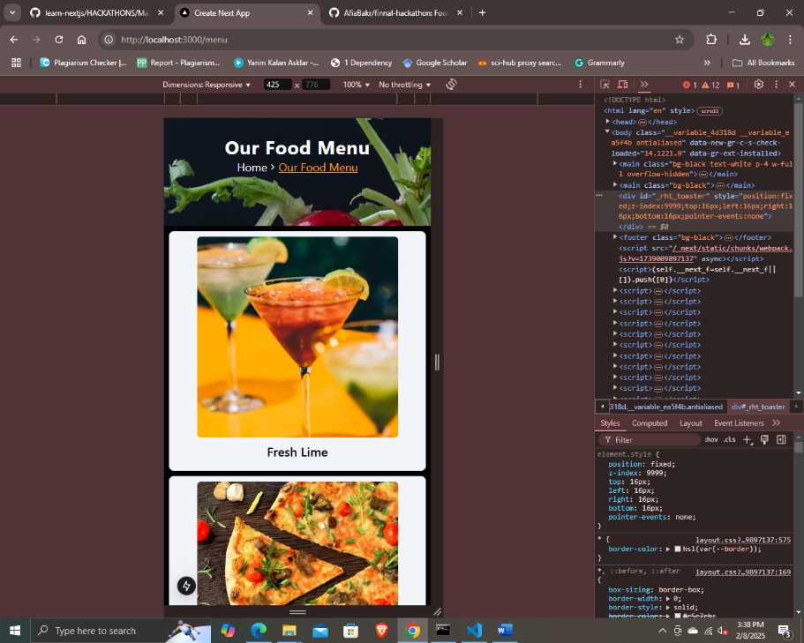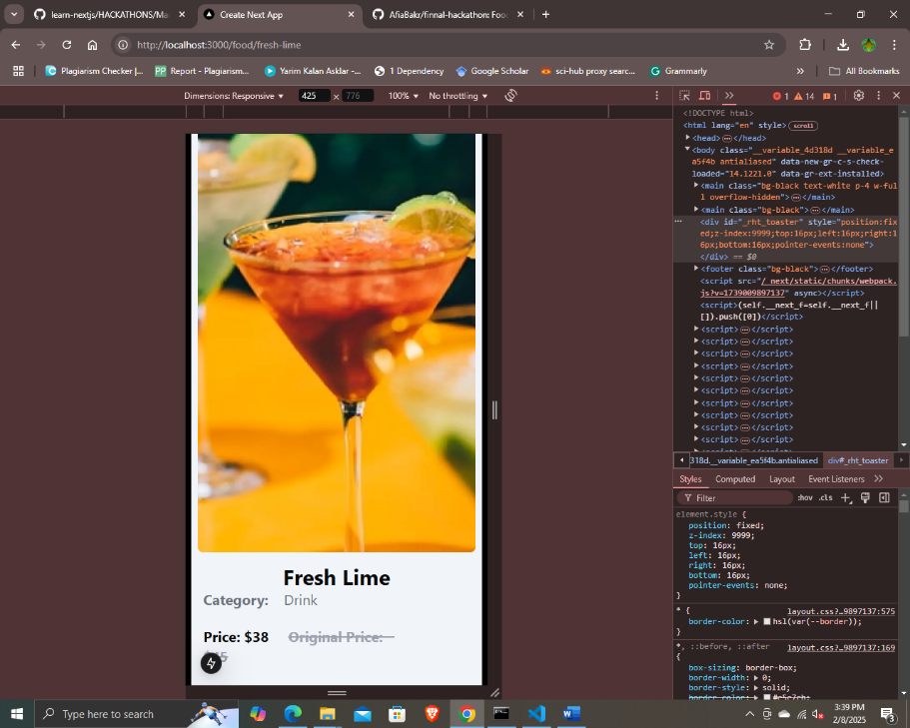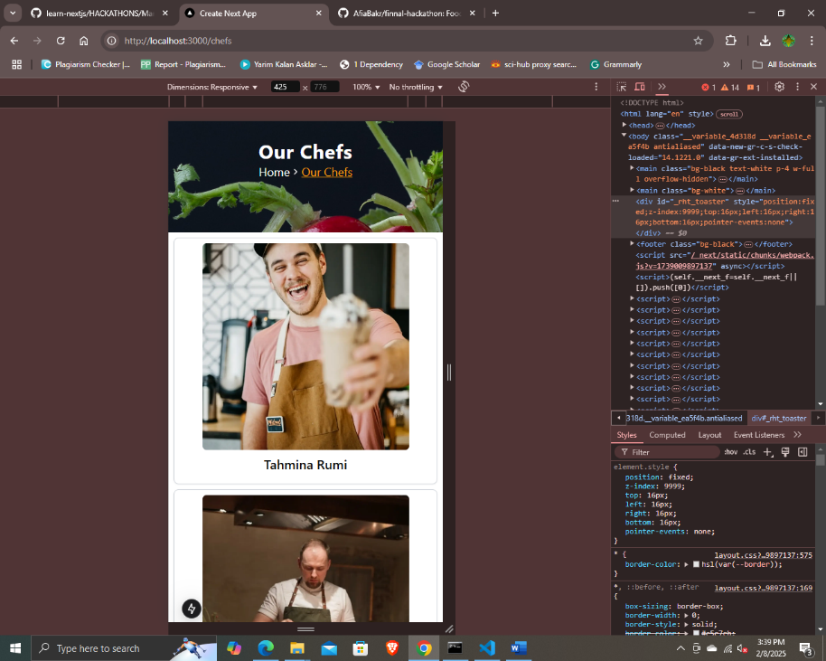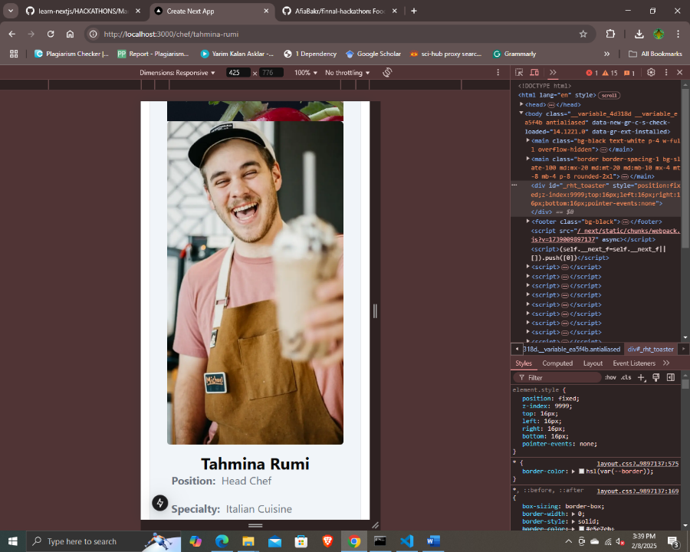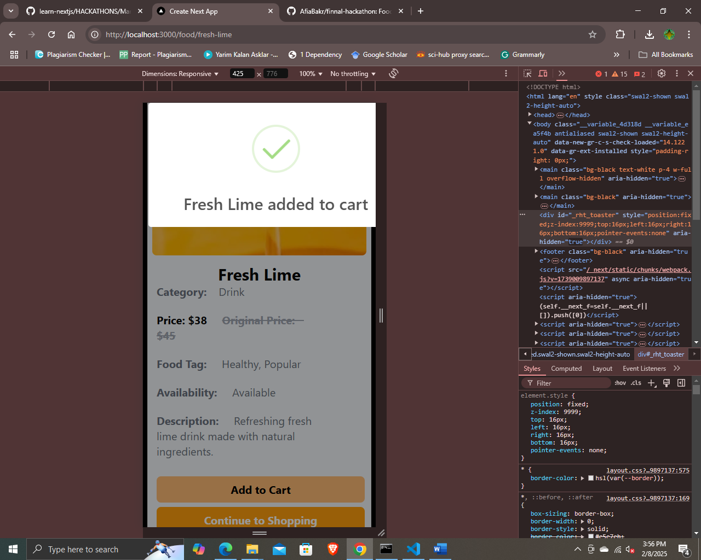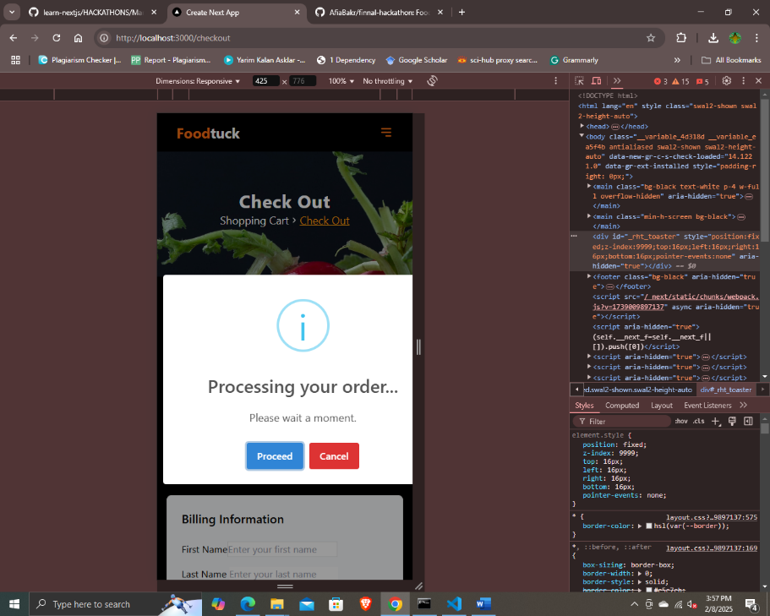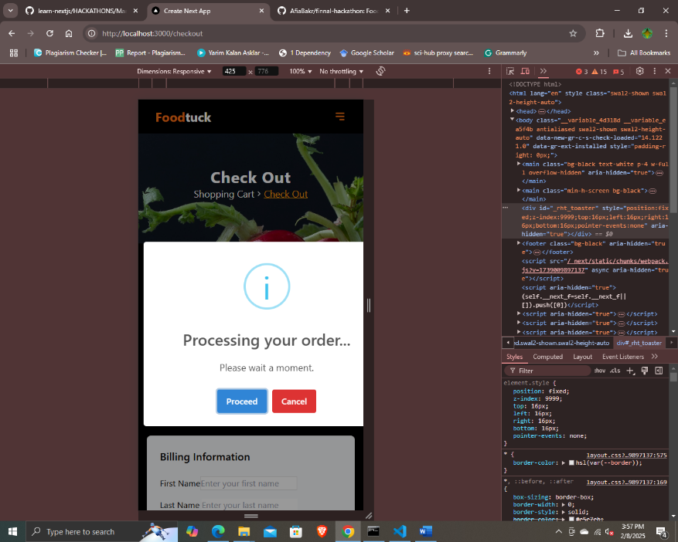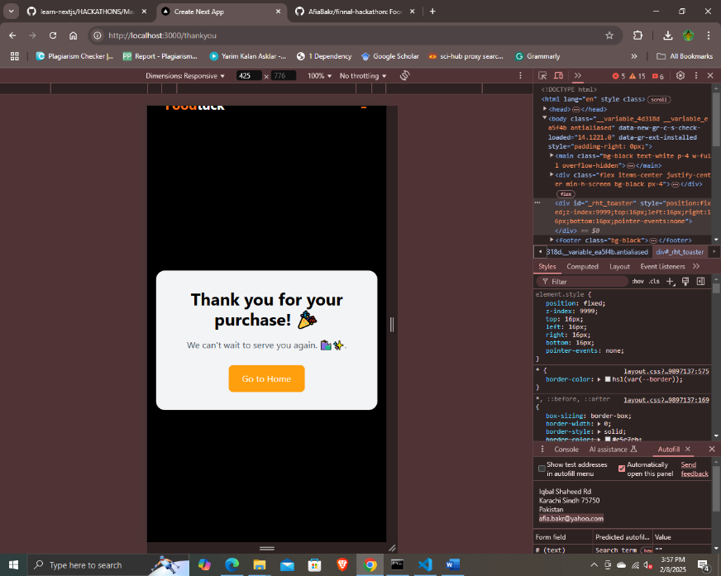

Food Restaurant website ensures a seamless and user-friendly experience with a fully functional **Hero Section, Menu, and Chef Pages**. You can easily **add items to the cart, remove them**, and smoothly **proceed to checkout**—all while ensuring data is **fetched properly from Sanity**. Every element is **fully responsive**, providing an effortless browsing experience on any device

Food GET from API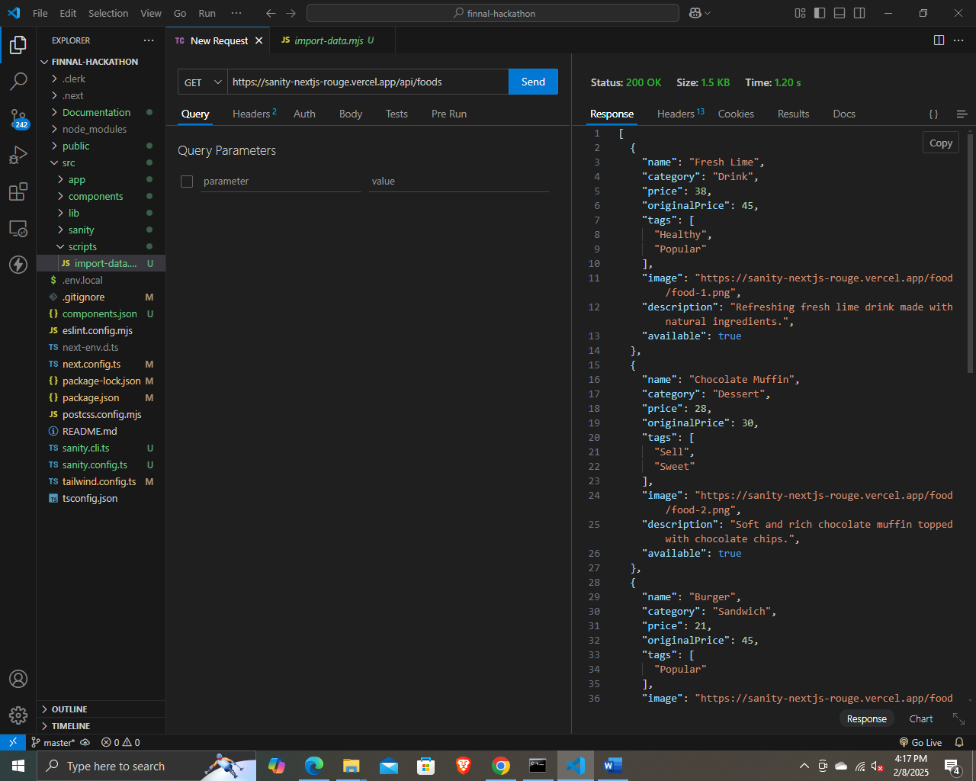

Chef GET from API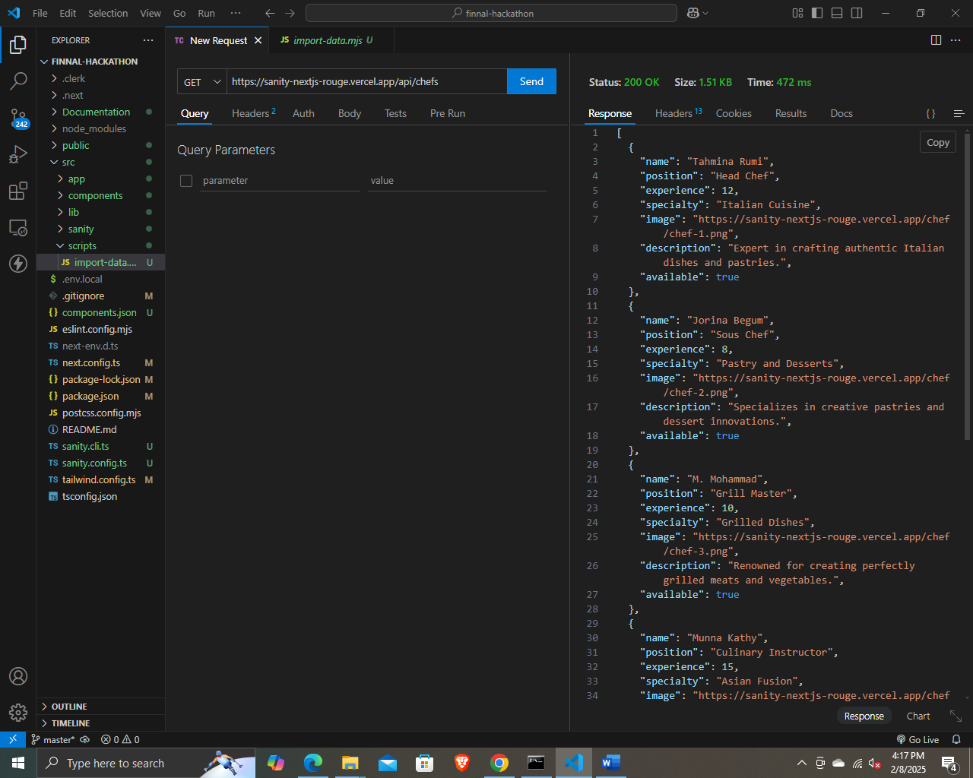

* Components. Logs or reports from testing tools (e.g., Lighthouse, Postman

1. Install in project terminal

“npm install -g lighthouse”

1. Run in terminal

“npm fund”

1. Run in terminal

“lighthouse http://localhost:3000 –view”

Link=file:///E:/Governer%20Generative%20AI%20Course/GIAIC/Afia%20Bakr/Quarter%202%20GIAIC/hackathons/finnal-hackathon/localhost_2025-02-08_18-26-57.report.html

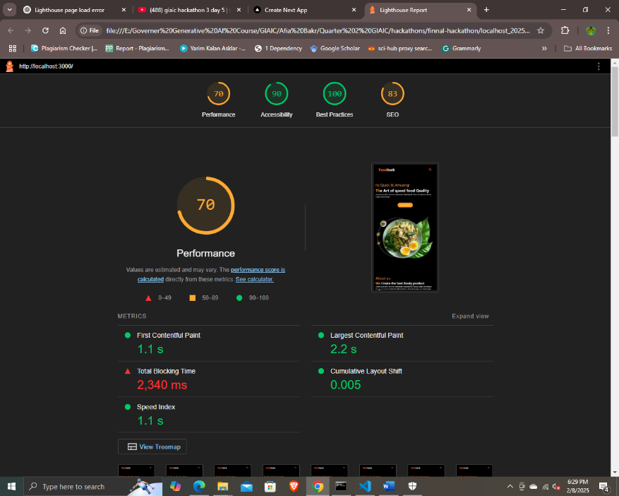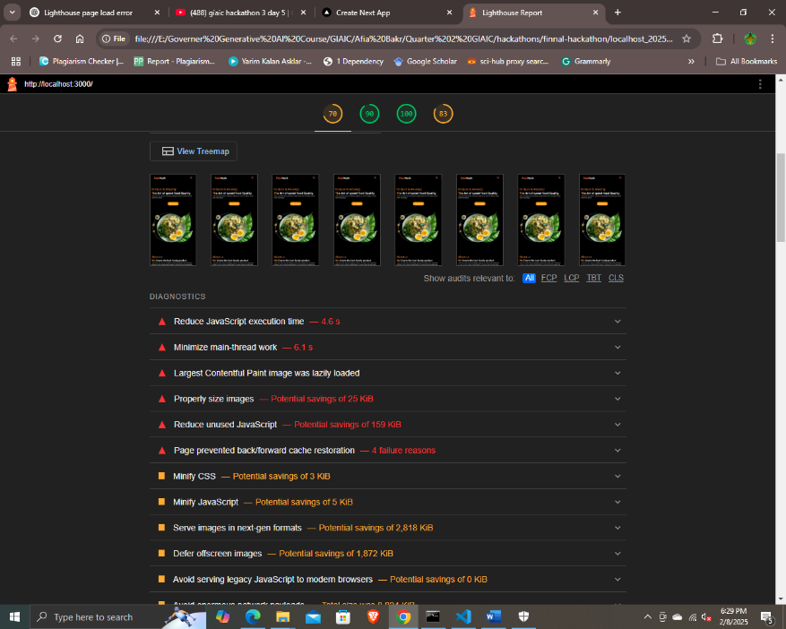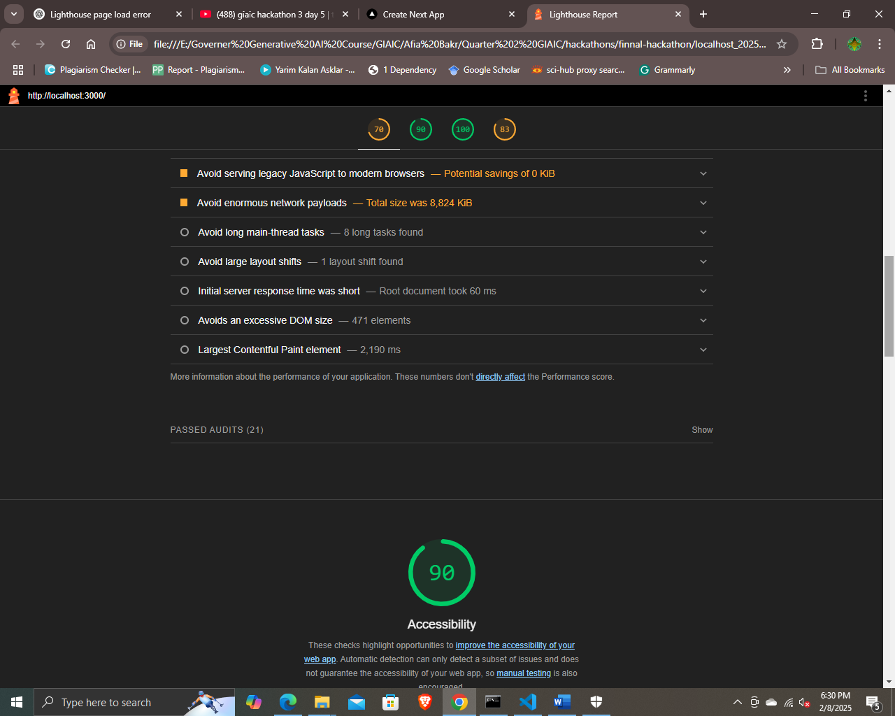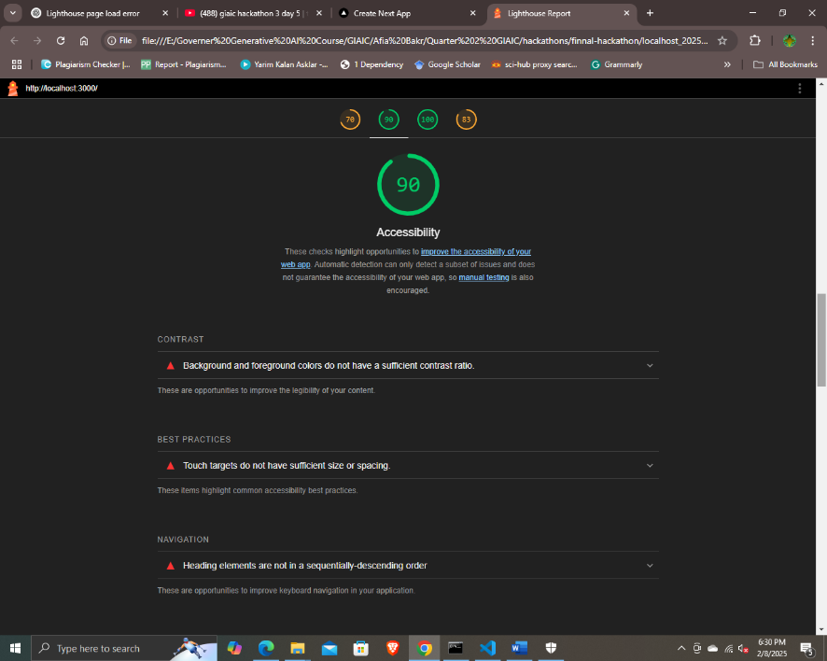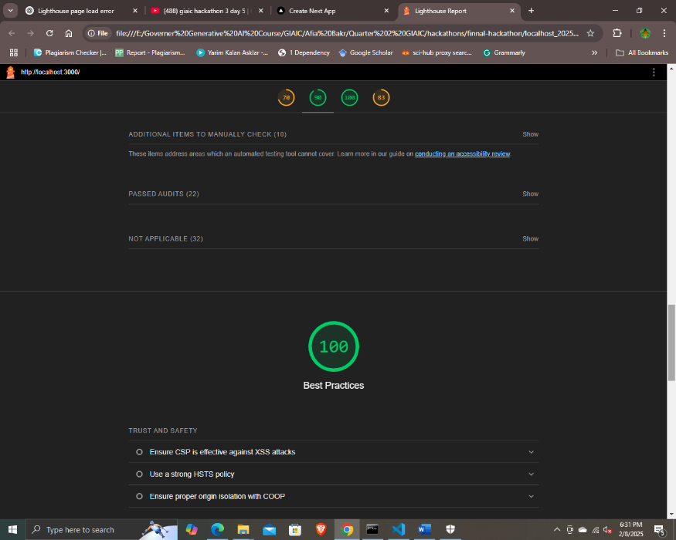

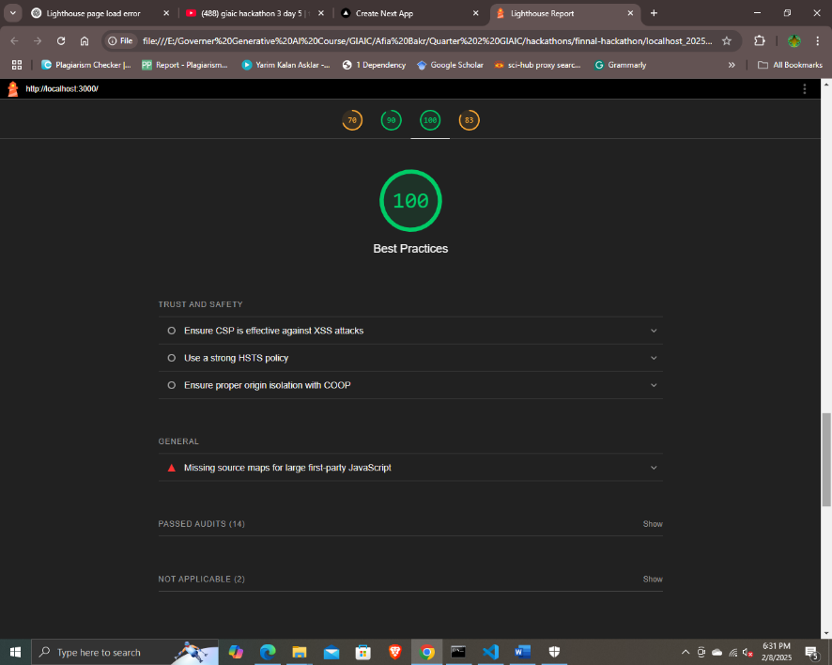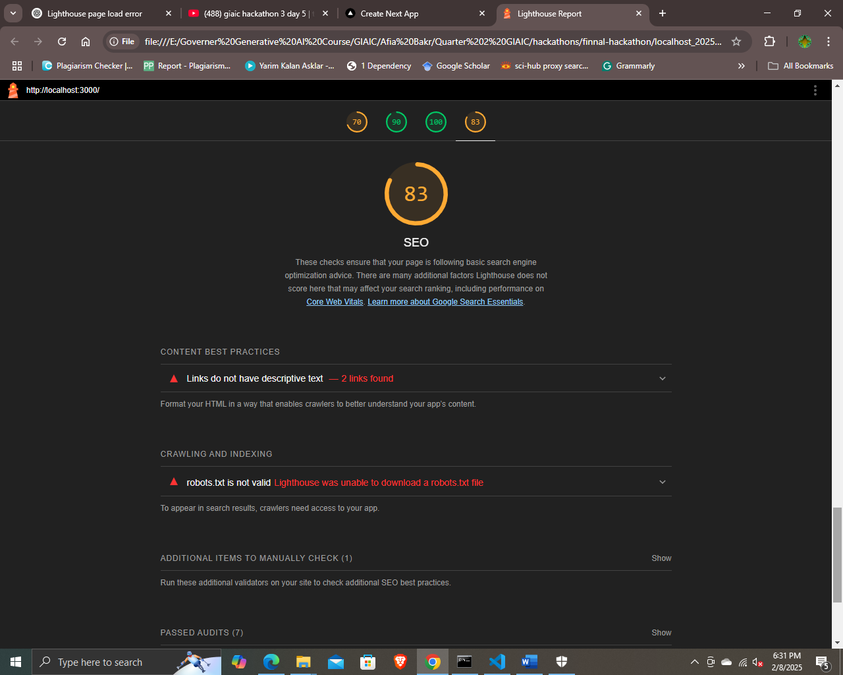

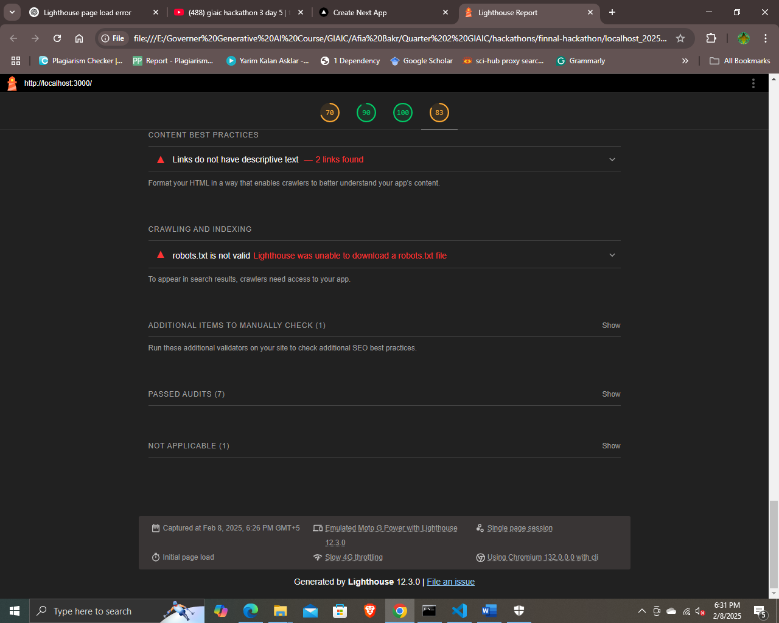

Lighthouse Tree map:

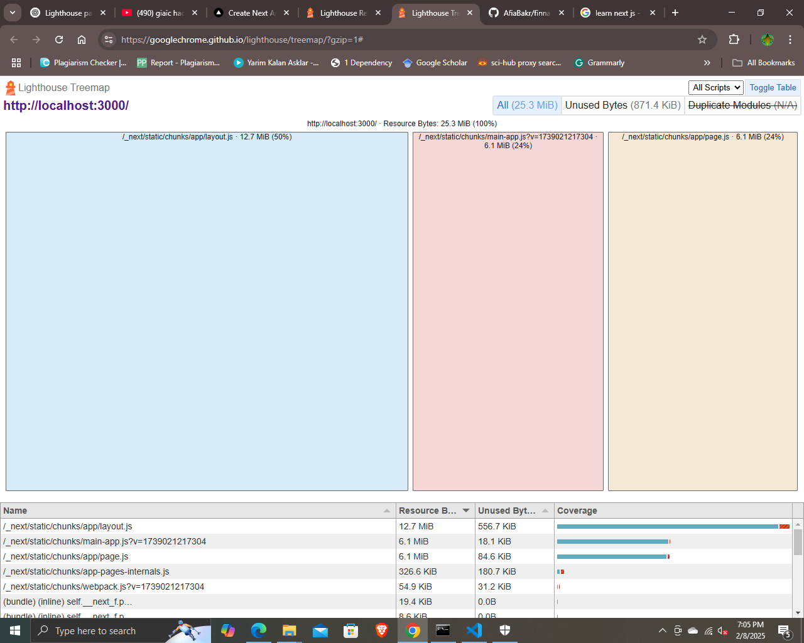

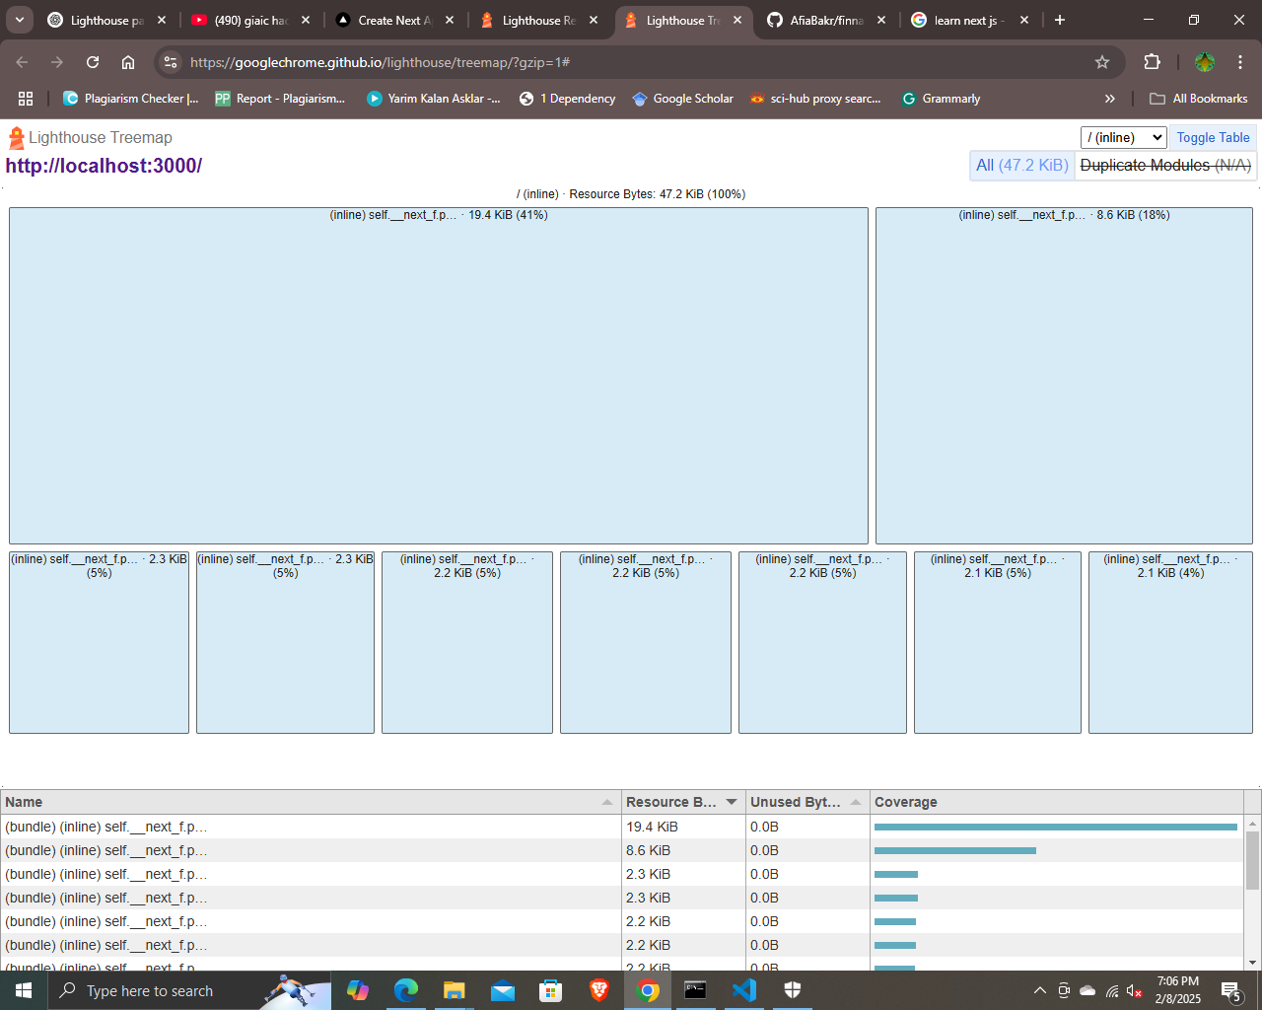

Developer Resources:

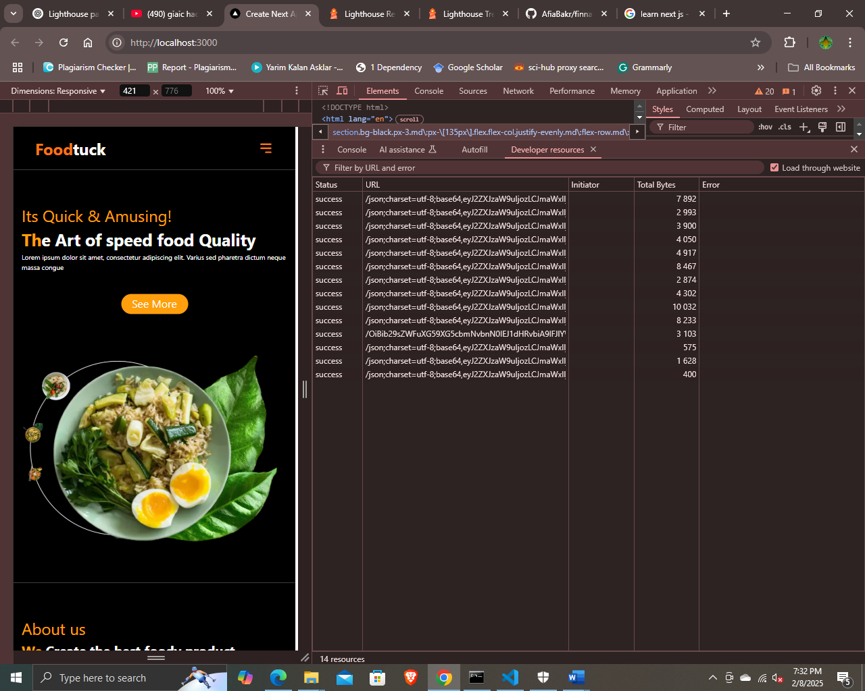

Performance Monitor:

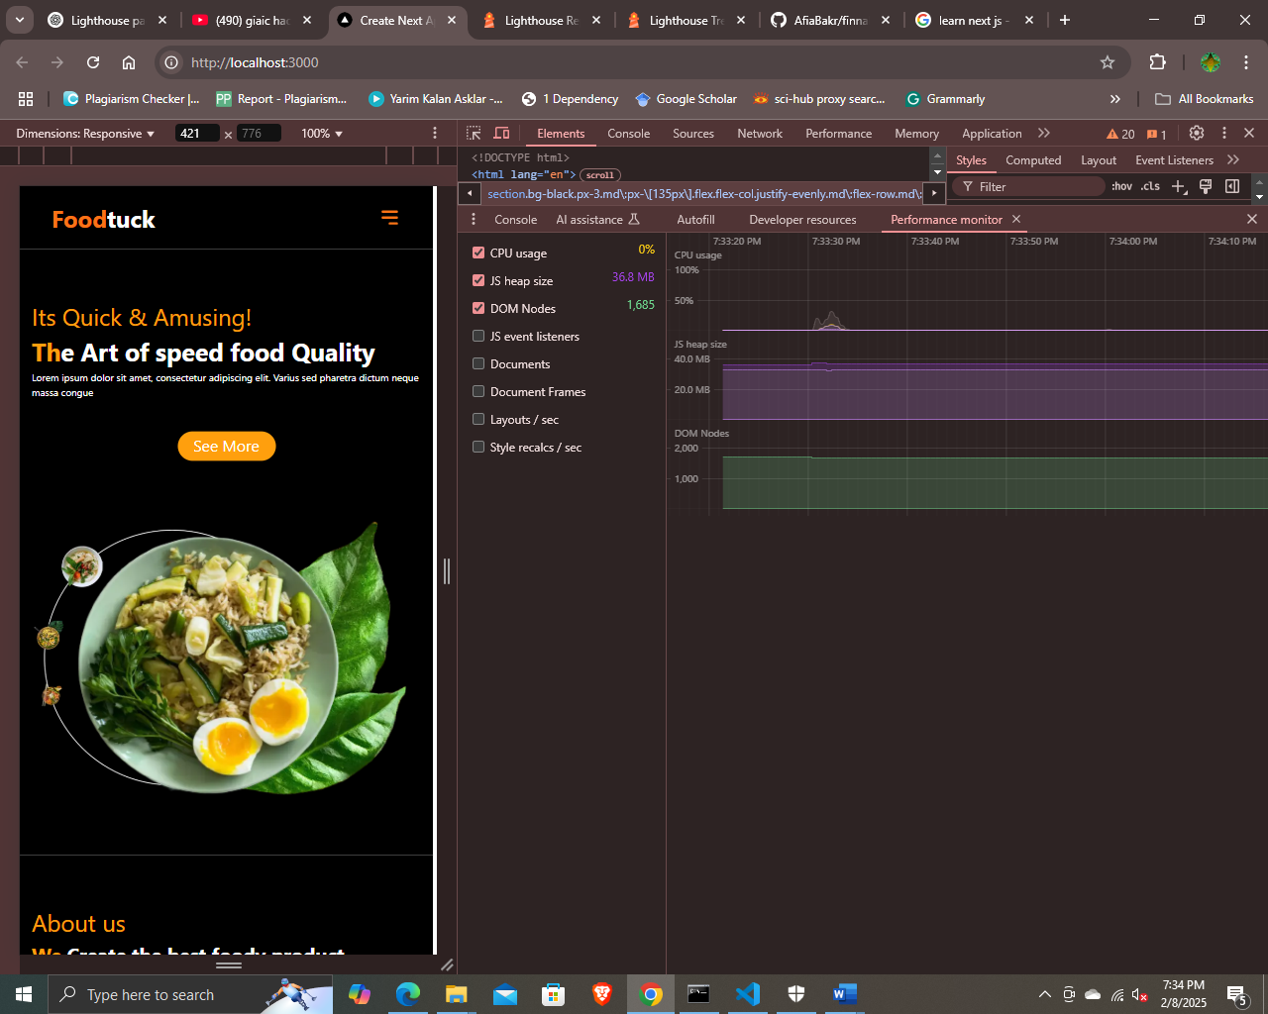

Issues:

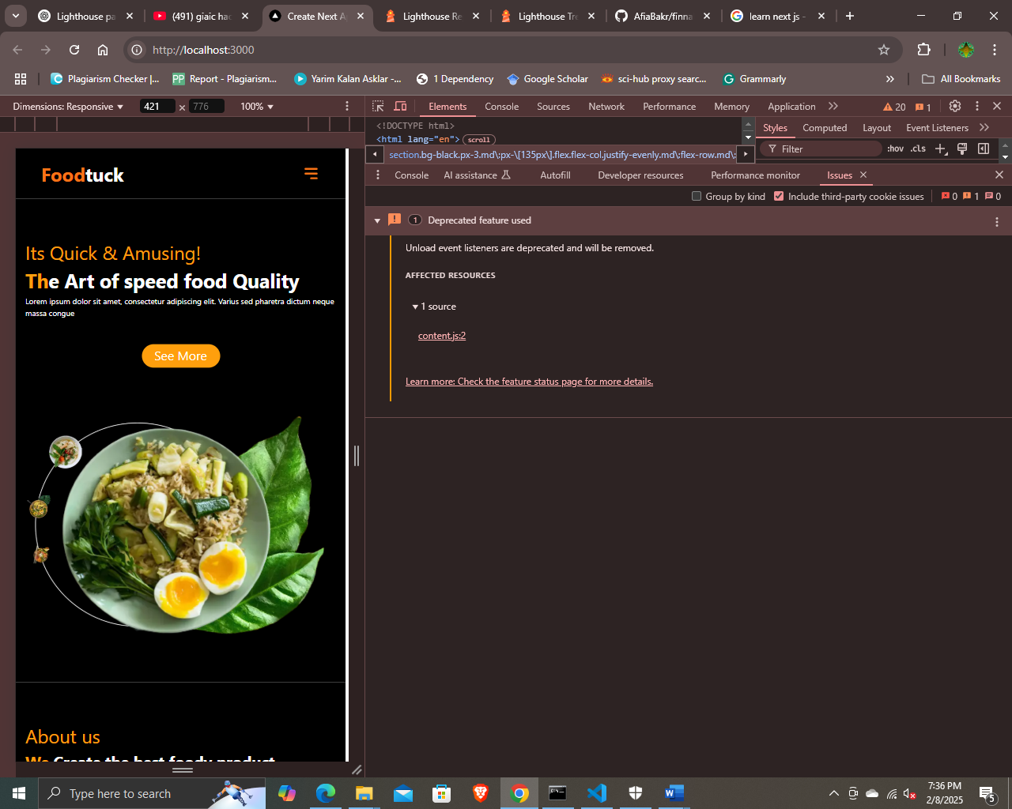

Security:

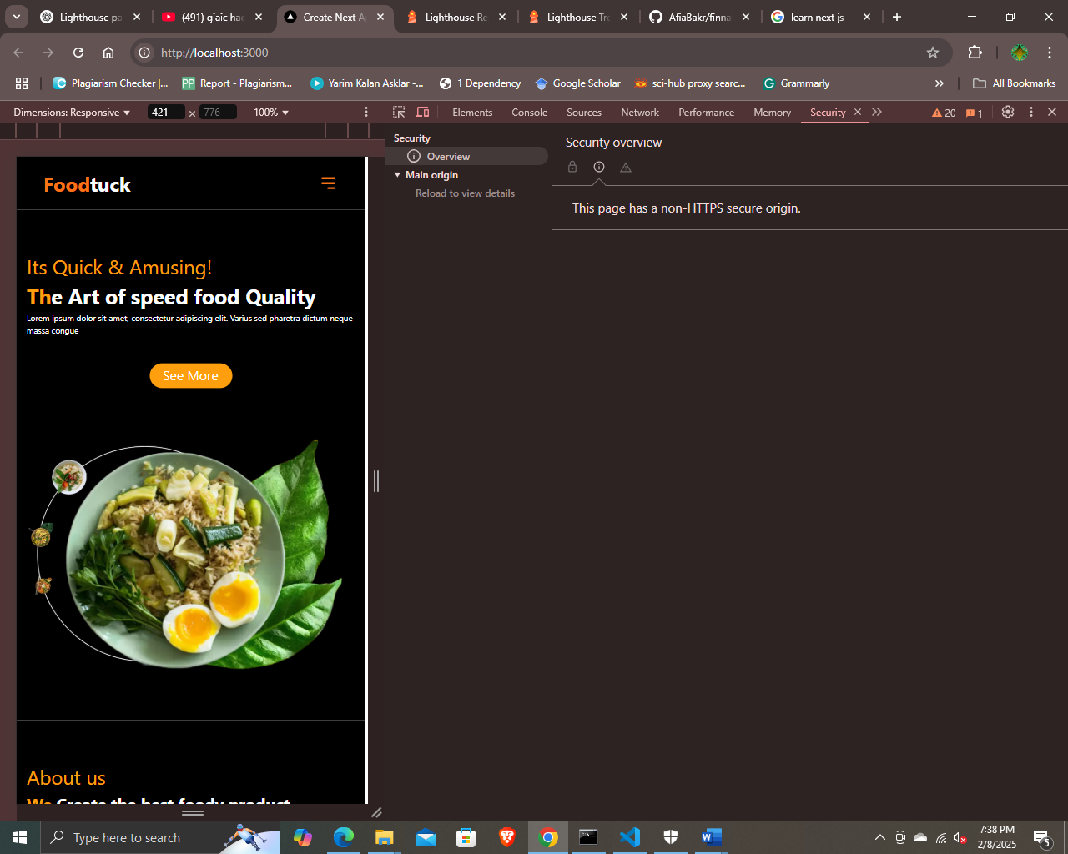

3. Documentation:

1. Test cases executed and their results

Website ensures that all products are displayed accurately, fetching real-time data from Sanity. Each product is showcased with high-quality images, detailed descriptions, and pricing for a seamless browsing experience. The layout is fully responsive, ensuring a smooth and user-friendly experience on all devices. Enjoy effortless navigation while exploring our product range!

1. Performance optimization steps taken.
   1. *Install in project terminal:*

“npm install -g lighthouse”

* 1. *Run in terminal:*

“npm fund”

* 1. *Run in terminal:*

“lighthouse http://localhost:3000 –view”

* 1. *Get lighthouse Report:*

*Link*

<file:///E:/Governer%20Generative%20AI%20Course/GIAIC/Afia%20Bakr/Quarter%202%20GIAIC/hackathons/finnal-hackathon/localhost_2025-02-08_18-26-57.report.html>

1. Security measures implemented.

These are in “.env.local” file which does not upload in GitHub

1. NEXT_PUBLIC_SANITY_PROJECT_ID
2. NEXT_PUBLIC_SANITY_DATASET
3. SANITY_API_TOKEN
4. Challenges faced and resolutions applied.

Whenever I encounter an error or struggle to understand a code snippet or function, I seek help from my teachers, classmates, and ChatGPT. Additionally, I explore GitHub ( Panaverse learn Next.js, Sir Ameen Alam, Sir Ali Jawad, and Sir Mubashir Repositories) for relevant solutions. This collaborative approach helps me quickly resolve issues and deepen my understanding of complex concepts.

4. Repository Submission:

https://github.com/AfiaBakr/finnal-hackathon.git

|  |  |  |  |  |  |  |  |  |  |
| --- | --- | --- | --- | --- | --- | --- | --- | --- | --- |
| **Sno.** | **Test Case ID** | **Test Case Description** | **Test Steps** | **Expected Result** | **Actual Result** | **Status** | **Severity Level** | **Assigned To** | **Remarks** |
|  |  |  |  |  |  |  |  |  |  |
|  | TC001 | Validate product listing page | Open product page > Verify products | Products displayed correctly | Products displayed correctly | Passed | High |  | No issues found |
|  | TC002 | Test API error handling | Disconnect API > Refresh page | Show fallback UI with error message | Error message shown | Passed | High |  | Handled gracefully |
|  | TC003 | Check cart functionality | Add product to cart > Verify cart contents | Cart updates with added product | Cart updates as expected | Passed | High |  | Works as expected |
|  | TC004 | Ensure responsiveness on mobile | Resize browser window > Check layout | Layout adjusts properly to screen size | Responsive layout working as intended | Passed | High |  | Test successful |
|  |  |  |  |  |  |  |  |  |  |

**2. Testing Report (CSV Format)**

Checklist for Day 5:

* Functional Testing: • ✔
* Error Handling: • ✔
* Performance Optimization: • ✔
* Cross-Browser and Device Testing: • ✔
* Security Testing: • ✔
* Documentation: • ✔
* Final Review: • ✔